Pestaña 1
Big Data Final Exercise
Beatriz Sánchez Espada

Index

Data extraction 1
Data Preprocessing 1
PCA Analysis 2
t-SNE Analysis 3
K Means clustering 5
Elbow Method 5
K-Means Clustering 5
Heatmap for gene expression 6
K-Nearest Neighbors (KNN) Classification 7
RNA-seq Neural Networking 8
Conclusion 9

Data extraction
In this analysis we are going to analyze RNA-Seq (HiSeq) data from UC Irvine repository to classify five distinct tumor types based on gene expression: BRCA (Breast Invasive Carcinoma), KIRC (Kidney Renal Clear Cell Carcinoma), COAD (Colon Adenocarcinoma), LUAD (Lung Adenocarcinoma), and PRAD (Prostate Adenocarcinoma).
Breast Invasive Carcinoma (BRCA) is the most common cancer in women, originating in the breast tissue and often classified based on hormone receptor status (ER, PR, HER2). Kidney Renal Clear Cell Carcinoma (KIRC) is the most frequent subtype of kidney cancer, characterized by clear cells and mutations in the VHL gene, leading to abnormal blood vessel growth. Colon Adenocarcinoma (COAD) is a malignant tumor that starts in the colon’s glandular cells, often progressing from benign polyps and driven by Wnt/β-catenin signaling mutations. Lung Adenocarcinoma (LUAD) is the most prevalent subtype of lung cancer, frequently found in both smokers and non-smokers, and commonly associated with mutations in EGFR, KRAS, or ALK genes. And finally, Prostate Adenocarcinoma (PRAD) is the most common cancer in men, originating in the prostate gland and heavily influenced by androgen signaling, which regulates tumor growth.

Data Preprocessing

Firstly, we process gene expression data to prepare it for the different techniques, like Principal Component Analysis (PCA) or t-SNE. The goal is to clean, normalize, and filter the data so that it can be analyzed effectively.

We begin by loading several essential R libraries that assist with data manipulation, visualization, and statistical analysis. The stats, ggplot2, and gplots packages help us with various statistical and graphical functions, while readr ensures efficient reading of CSV files. The RColorBrewer package allows us to use appealing color schemes for visualization. Additionally, class and caret provide useful tools for classification and predictive modeling. Since we are dealing with gene expression data, edgeR is particularly important for normalizing count-based data, and Rtsne enables us to perform t-SNE, a technique used for reducing high-dimensional data into a more interpretable form.

Once we have the necessary libraries, we load our datasets. The data.csv file contains gene expression values, where rows represent different samples and columns correspond to different genes. At the same time, labels.csv provides sample annotations, ensuring that we can properly categorize our data later. Next, we clean the dataset by removing any genes that contain only zero values across all samples. These genes do not contribute useful information and may interfere with statistical analysis.

To normalize the remaining data, we use the edgeR package, which helps correct for differences in sequencing depth between samples. First, we convert our dataset into a DGEList object, a format designed for count-based gene expression data. We then calculate normalization factors using calcNormFactors(), which adjusts the data so that comparisons between samples are fair. Finally, we transform the data into log-transformed CPM (Counts Per Million) values using cpm (dge, log = TRUE), ensuring that our expression values are more comparable across samples.

After normalization, we filter out genes with low variance, keeping only the most informative ones. To do this, we calculate the variance of each gene across all samples and remove those that fall below the 25th percentile. Genes with little variation are less likely to be useful in distinguishing between different sample groups, so filtering them out improves the quality of our dataset for downstream analysis.

Finally, we ensure that our gene expression data and sample labels align correctly. We identify the samples that appear in both filtered_data and label_pca and retain only those that are present in both datasets. This step is crucial because any mismatch between our gene expression values and their corresponding labels could lead to incorrect conclusions during analysis and computational errors.

PCA Analysis
The Principal Component Analysis (PCA) is done on this data to reduce dimensionality and visualize it. By transforming high-dimensional data into a lower-dimensional space, PCA allows us to explore the main sources of variation and determine whether distinct sample groups emerge, based on gene expression differences.
In first place, to compute PCA, we apply the prcomp() function to filtered_data, which calculates principal components that capture the most variance in the dataset. These components represent new axes along which the data is projected, prioritizing the directions that maximize variability. Also, by focusing on the first two principal components (PC1 and PC2), we can retain much of the dataset structure while simplifying its complexity.
Next, we prepare the data for visualization by creating a data frame (df_pca) containing the first two principal components (PC1, PC2) along with the corresponding sample labels. Finally, we use ggplot2 to generate a scatter plot where each point represents a sample, colored according to its cluster.
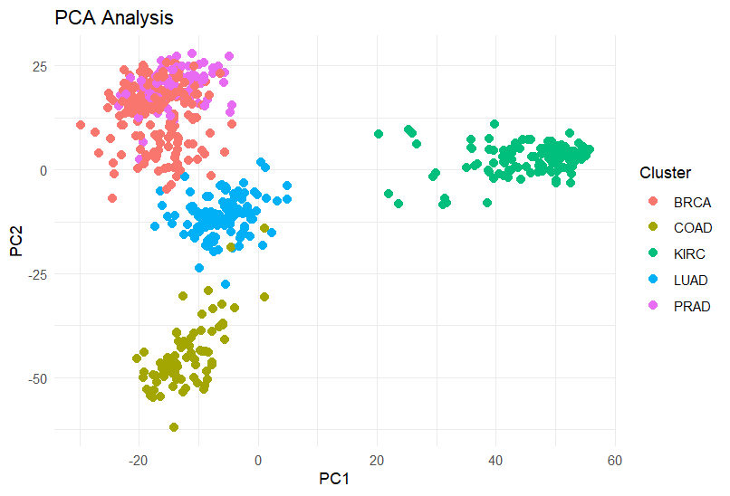
Figure 1. PCA Analysis
We can see that some cancer types form distinct clusters, such as KIRC (green) and COAD (yellow), which are well separated along PC1. However, BRCA (red) and PRAD (pink) are closer together, suggesting some similarity in their expression profiles along the first two principal components. This indicates that while PCA effectively captures global variance, it may not always perfectly separate all tumor types if the variance is spread across multiple dimensions.

t-SNE Analysis
T-SNE is another method of reducing the dimensionality of our gene expression data but more used to identifying clusters and patterns in the data. We use the Rtsne() function, applying it to filtered and normalized data (filtered_data), with perplexity = 30 to balance local and global structure retention.
Once the t-SNE transformation is complete, we organize the results into a data frame (df_tsne), containing the two new coordinates (X, Y) and the corresponding sample labels. Again, as in the PCA we use ggplot2 to generate a scatter plot, where each point represents a sample, color-coded by its assigned cluster.

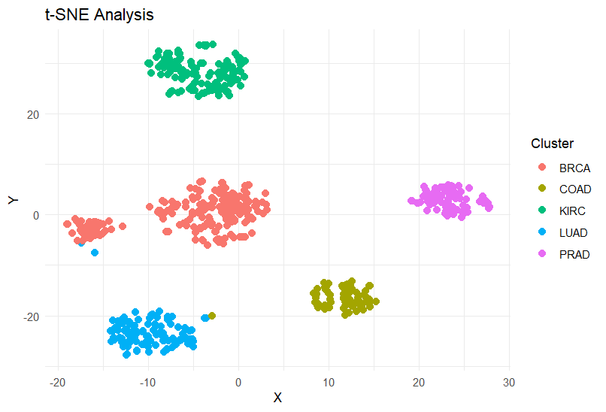
Figure 2. t-SNE Analysis
The t-SNE plot effectively separates different tumor types into distinct clusters based on gene expression patterns. Each cluster is represented by a unique color, with minimal overlap, indicating that tumors of different types exhibit unique molecular signatures. This strong separation suggests that gene expression data contain enough information to classify cancer types accurately.
While both t-SNE and PCA (Principal Component Analysis) are used for dimensionality reduction, they serve different purposes. PCA is a linear method that reduces dimensions by capturing the directions of maximum variance in the data, making it useful for understanding global patterns while t-SNE is a non-linear technique that focuses on preserving local relationships.
As we can see in the case of the BRCA and PRAD tumors, PCA may not always reveal clear clusters when the data have complex, non-linear relationships.That is why t-SNE plot is particularly useful for identifying biologically meaningful subgroups in gene expression studies.

K Means clustering

Elbow Method
To determine the optimal number of clusters, we first use the elbow method, a technique that evaluates the within-cluster sum of squares (WSS) for different values of k.
The WSS measures the compactness of clusters, with lower values indicating that samples within a cluster are more similar to each other. By running a loop from k = 1 to k = 10, we apply K-Means clustering to the filtered gene expression data and store the WSS values. The results are then plotted, showing the relationship between the number of clusters and WSS.
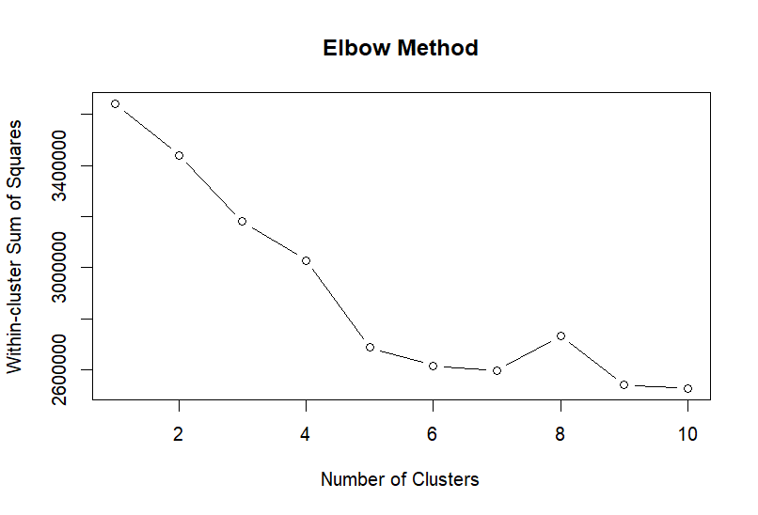
Figure 3. Elbow method plot
The optimal number of clusters is typically found at the "elbow point", where the curve starts to flatten. In this case the curve flattens at 5 clusters, matching the numbers of tumors from the database and meaning that adding more clusters does not significantly improve clustering quality.

K-Means Clustering
After selecting an appropriate number of clusters, we apply K-Means clustering to the data with k = 5. The nstart = 10 parameter ensures that the algorithm runs multiple times with different initial cluster centers to avoid poor local minima. The K-Means algorithm assigns each sample to a cluster based on gene expression similarities, and the results are stored in kmeans_result. This step helps us explore whether natural groupings exist within the dataset based on the gene expression profiles.
To visualize the clustering results, we use Principal Component Analysis (PCA) and create a data frame (df) that includes the PCA-reduced data (PC1, PC2), the cluster assignments from K-Means (KMeans_Cluster), and the actual sample labels (True_Labels).
Using ggplot2, we generate two scatter plots: one showing the K-Means clustering results (where points are colored by their assigned cluster) and another displaying the true labels (colored by their actual biological class). These plots help us visually compare whether the K-Means clusters correspond well to the real biological groupings.
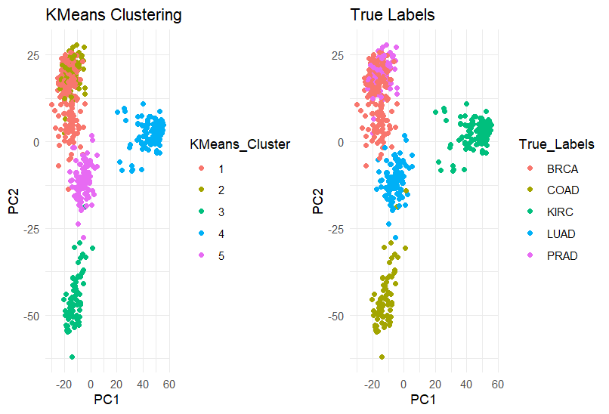
Figure 4. K-means cluster vs true labels cluster
The K-Means clustering plot shows a perfect alignment with the true labels, demonstrating that gene expression patterns naturally segregate tumors into distinct biological groups. This strong separation suggests that the underlying expression profiles capture meaningful biological differences between tumor types, reinforcing the validity of these molecular signatures for classification and potential biomarker discovery.

Heatmap for gene expression
By creating a heatmap we are looking to visualize gene expression variability and highlight patterns and potential clusters in the data by selecting samples with the highest variability.
We first calculate the standard deviation for each gene and filter the most variable ones, keeping a maximum of 50 genes. Next, we define a color palette (GnBu) for expression levels and map sample group labels (tf) to colors using the Dark2 palette. We ensure color assignments match the selected genes. Finally, we use heatmap.2() to plot the heatmap, labeling genes (columns) and samples (rows), applying row-wise normalization, and using ColSideColors to differentiate sample groups.
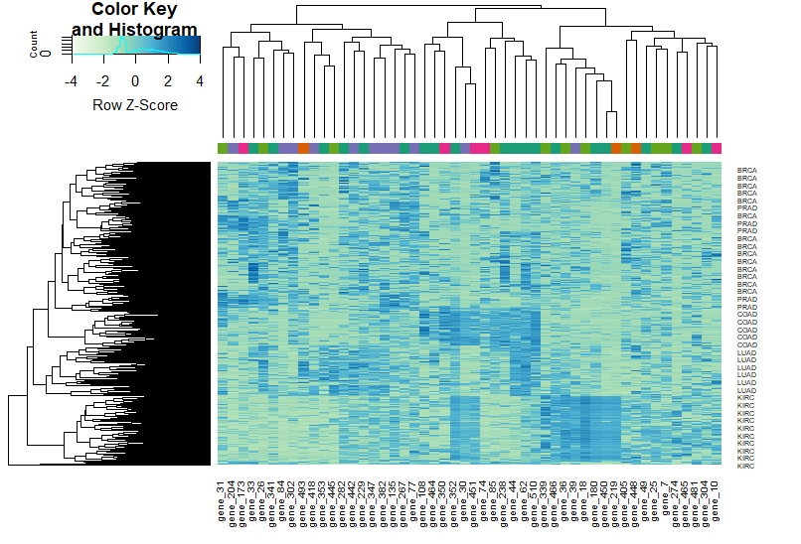
Figure 5. Heatmap of gene expression
The clustering of the different genes according to each tumor suggests functionally related genes with similar expression profiles. This analysis could help identify biomarkers and cancer-specific expression signatures, aiding in machine learning applications in classification and potential therapeutic targeting.

K-Nearest Neighbors (KNN) Classification
The goal is to assess how well KNN can classify the samples and analyze how the training size effects model performance.
First, we split the dataset into training and testing sets. Using set.seed(123), we ensure reproducibility. The script randomly selects 50% of the data for training, extracting the first 10 features from filtered_data as input (train_x and test_x) and their corresponding class labels (train_y and test_y). We then apply KNN with k = 5 using the knn() function, predicting class labels for the test data. Finally, we compute a confusion matrix with confusionMatrix() and calculate the error rate as 1 - Accuracy, giving us an initial performance measure.
Next, we perform a training size experiment to examine how the amount of training data influences KNN's error rate. We define different training sizes ranging from 10% to 90% of the total dataset and run KNN for each size. The classifier is trained on each subset, and errors for both the training and test sets are recorded. The test error indicates generalization performance, while the training error shows how well the model fits the training data.
To visualize the results, we plot the error rates as a function of training size using ggplot2. Two lines represent training error (blue) and testing error (red).
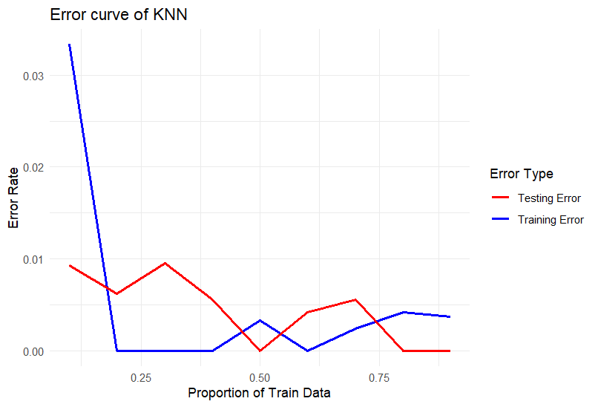
Figure 6. Testing and training curve error
As expected, the training error increases as more training data is used, since the model has fewer opportunities to memorize smaller datasets and must generalize better. Meanwhile, the testing error decreases, indicating improved performance and a better ability to make accurate predictions on unseen data. This trade-off highlights the model’s progression from overfitting (on smaller training sets) to a more generalized state as the dataset size increases.

RNA-seq Neural Networking
Finally we can implement a neural network using PyTorch to classify RNA-Seq gene expression data into the different tumor types.
We begin by loading the dataset using Pandas, converting the gene expression features into a NumPy array, and factorizing the tumor labels into numerical categories. To ensure consistency in our results, we fix random seeds across multiple libraries. Then, we split the data into training and test sets and convert them into PyTorch tensors for further processing.
Next, we define a simple neural network with one hidden layer containing 218 neurons and an output layer that corresponds to the number of tumor classes. To train our model, we utilize the Adadelta optimizer and negative log-likelihood loss, running for 20 epochs. We use DataLoaders to feed data in small batches, ensuring efficient training.
Finally, we evaluate our trained model on the test set. By comparing predicted labels with actual labels, we compute the accuracy, allowing us to assess how well our neural network classifies tumor types based on gene expression data.
By experimenting with different batch sizes, we observe variations in test accuracy. When setting the batch size to 6, we achieve a test accuracy of 77.5%, indicating that batch size plays a significant role in model performance.
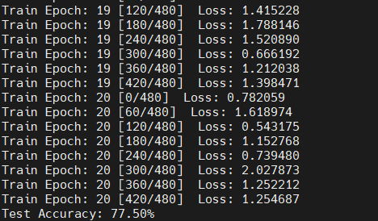
Figure 7. Output of neural network script

Conclusion
This study successfully demonstrates that RNA-Seq gene expression data can be used to classify different tumor types with high accuracy. By employing various machine learning techniques, including PCA, t-SNE, K-Means clustering, K-Nearest Neighbors (KNN), and neural networks, we identified patterns and relationships within gene expression data that distinguish different cancer types.

These findings reinforce the potential of deep learning in biomedical research, particularly for cancer classification. Future work could focus on fine-tuning hyperparameters, exploring deeper network architectures, or integrating multi-omics data for even more precise classification.

